|  |
| --- |
| Assignment 2 |
| Rongxin Yu, Weiyi Chen  Due on February 18, 2015 |

# 1. Impulse Responses

## Make plots of your impulses responses.

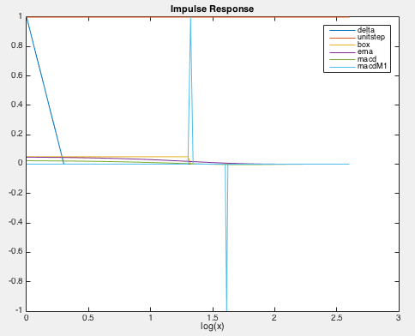

2. Data

## Plot your quote and trade data.

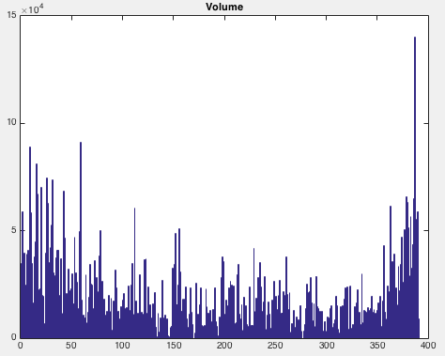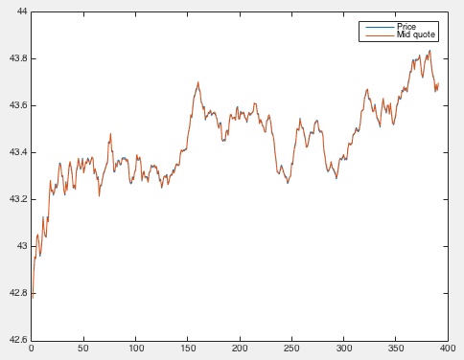

3. Truncation

## (a) Incorrect truncation: what is the length of the prices series and cand?

The length of price series and cand are 391 and 790, respectively.

## (b) Correct truncation: explain what this achieves

This assigns the first 391 elements of cand to y[].

4. Initialization

## (a) Incorrect initialization: overlay the original price series and explain your result.

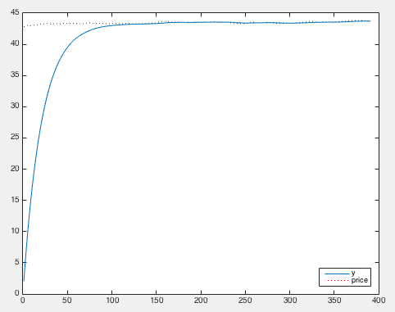

The convolution series is too small at the beginning part, because the overlay window is short and many of the summation terms are lost.

## (b) Correct initialization: overlay the original price series, explain the change from the previous version and describe the result now.

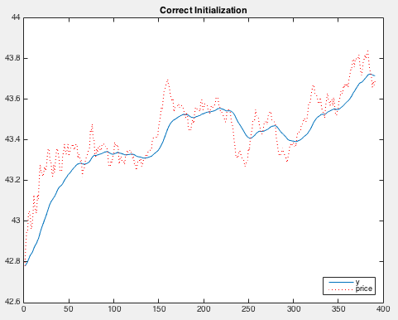

Since we subtract px[0] for convolution and add it back after convolution, we managed to adjust the error caused by the loss of summation terms at the beginning of the convolution series. Within full overlay area, the convolution result is almost the same (it will be the same if the gain of response is one, but since we truncate the response, the gain is a little smaller than one). For ranges at the beginning, this adjustment is like that we assume the price series is all px[0] before the starting point.

## (c) (In)Correct initialization: provide an explanation comparing the results.

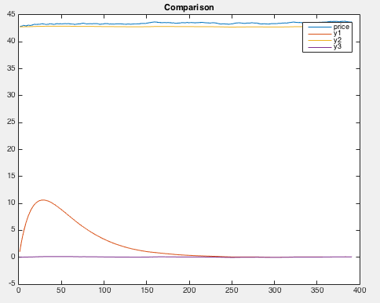 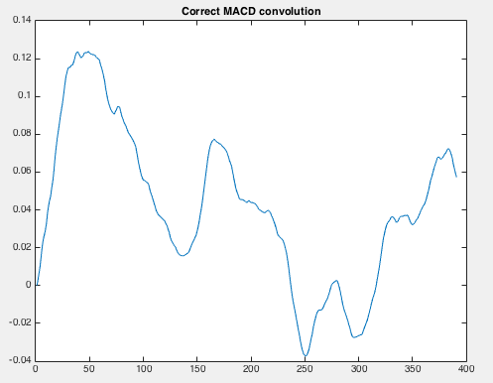

Since MACD is the subtraction of two ema series, similar to ema adjustments, we should first adjust price by subtracting px[0] and then add it back to the series. Since macd is a subtraction, the adding back is cancelled by the subtraction. Thus, the third one is correct.

5. Gain

## (a) Ema gain: in each case overlay the original price series and explain your result. Which gain is correct? Why have I multiplied the offset px[0] by the gain in the last term?

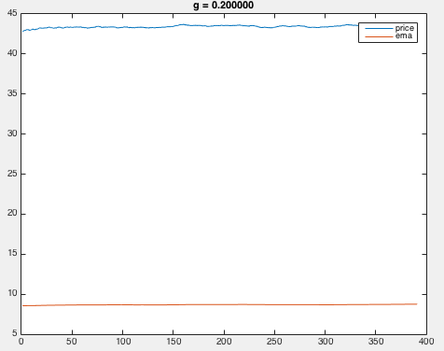

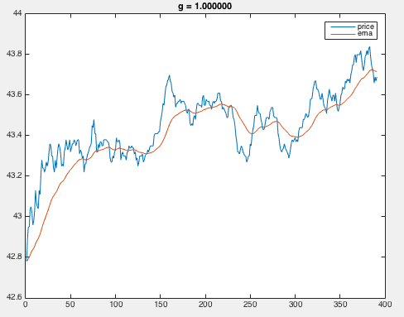 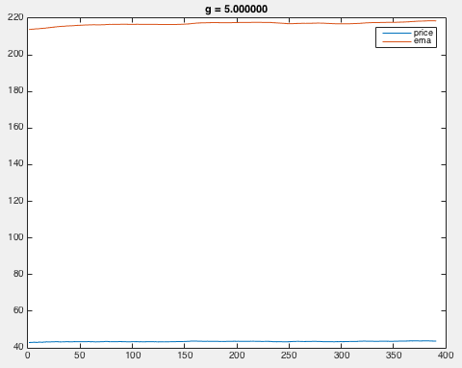

The picture with g = 1 is correct. The reason why we offset px[0] by g is that when we multiply h_ema by g, the subtraction of px will result in minus g*px[0] in total. Thus when we add px[0] back, we also need to multiply g.

## (b) Macd gain: what is wrong about all of these results? What is the gain of the macd impulse response itself? write an expression that shows that y3[n] in (4c) above is the correct way to initialize and compute the convolution with an macd.

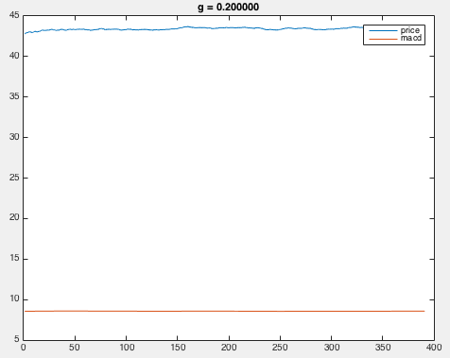

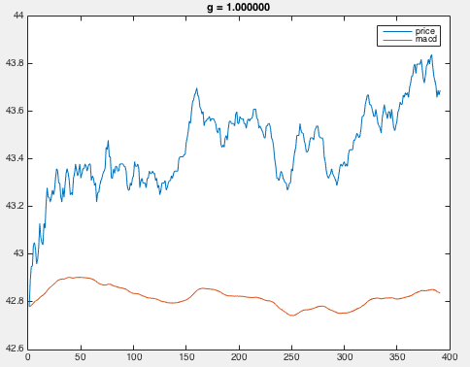 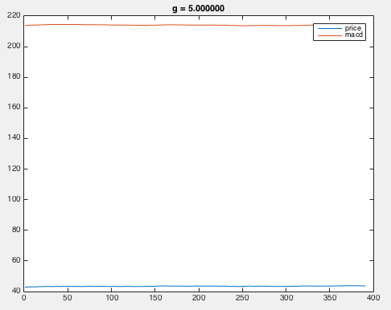

The problem lies in that we should not add g*px[0] back when we do macd. The gain of macd is zero. Like I mentioned in the previous question, macd is the subtraction of two ema, so when we do the adjustment, we only adjust the px series by subtracting px[0] before convolution. After convolution, the term g*px[0] are cancelled by the subtraction.

6. Ema of a Price Series

## Calculate and plot (in overlay) the ema impulse responses using the firstmoment sequence. convolve the price series with each ema and plot these results and overlay the original series. Explain your observations.

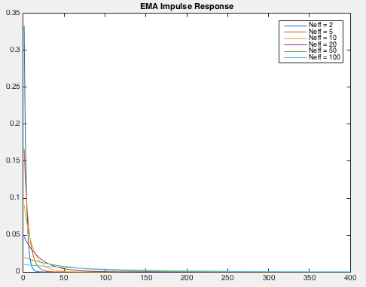 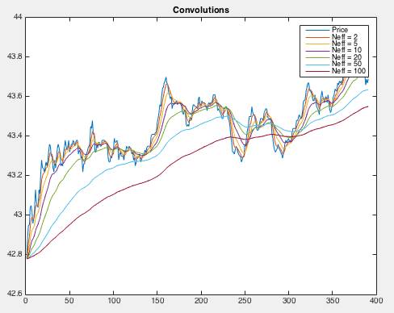

The smaller Neff is, the more weight ema put on the close terms, thus the convolution series is more like the original series. On the other hand, the larger Neff, the smoother the convolution series is.

7. Ema and Delay

## Overlay the ideal-delay results with the associated ema results for each Neff. Explain your observations.

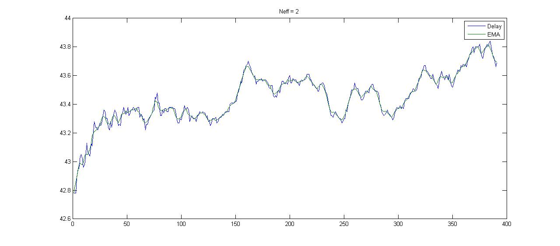

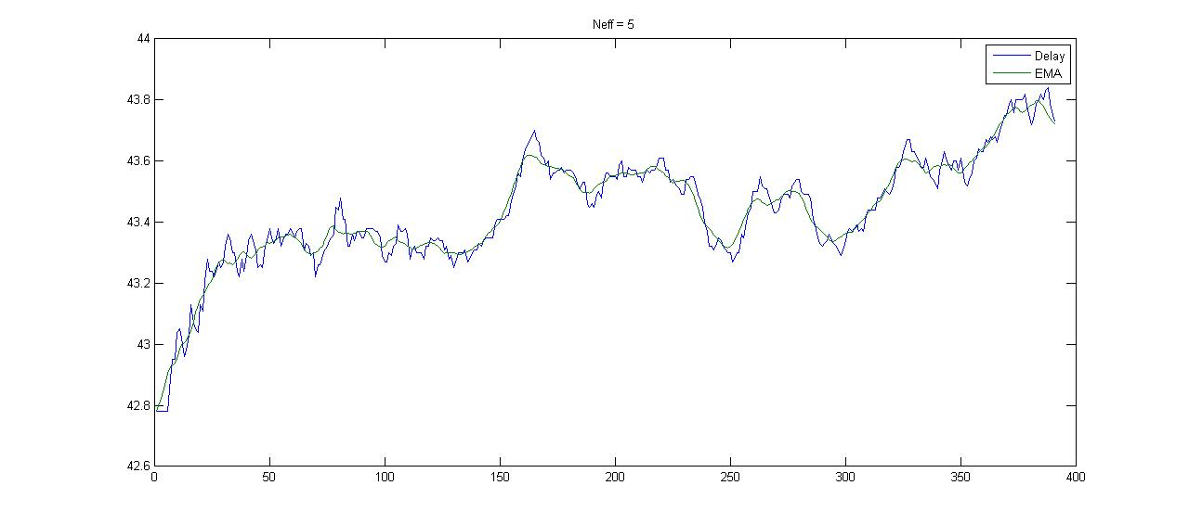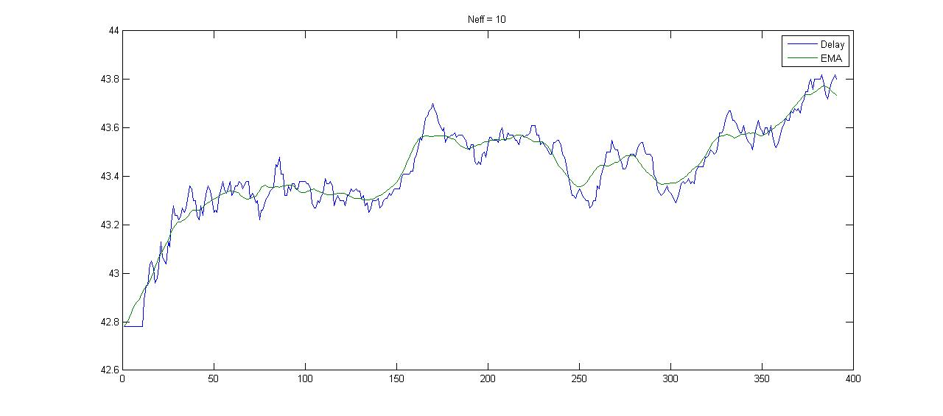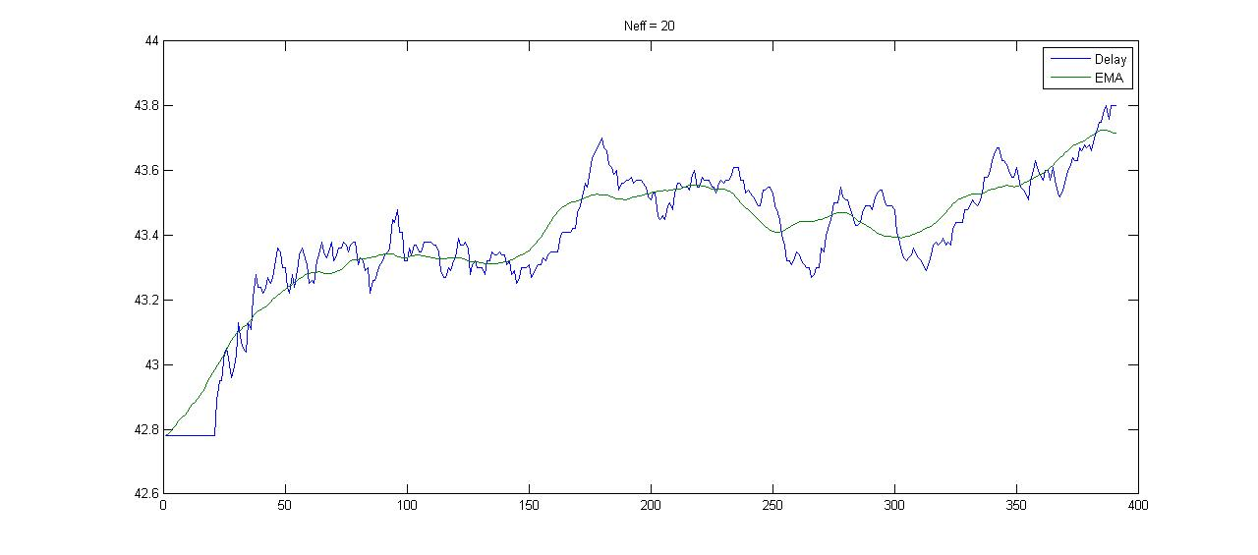

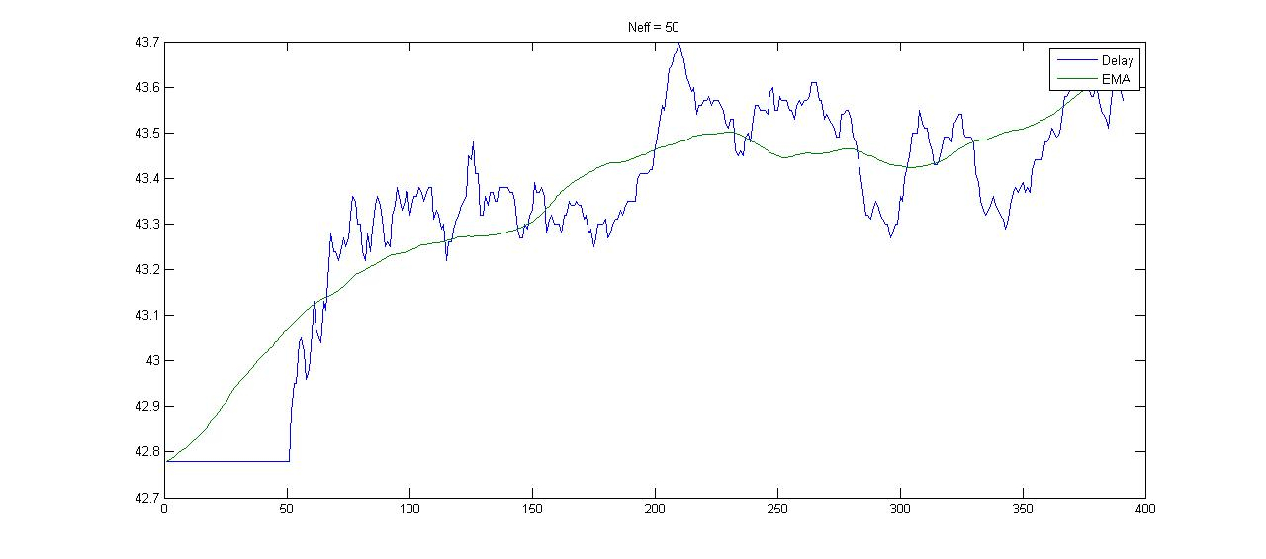

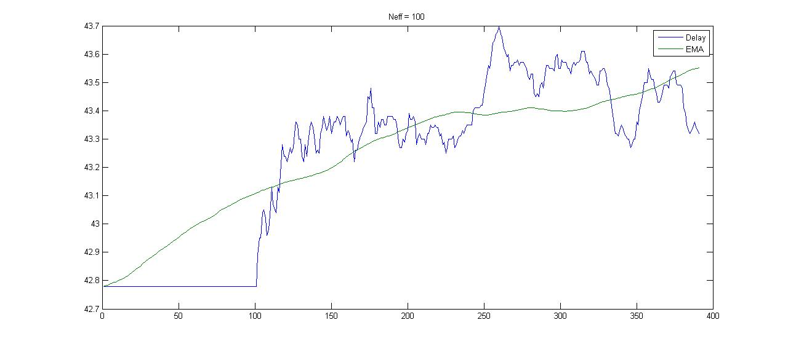

According to the graphs, the larger the value of Neff, the smoother the EMA line. EMA is taking historical data (previous Neff days) to obtain its value, so it reacts slower to the peak or trough, and the larger the value of Neff, the slower its reaction. By delay the price line as the value of Neff, we can see the peaks and troughs (almost) matching in each graph.

8 & 9. Macd-M1 of a Log-Price Series

## Explain your results.

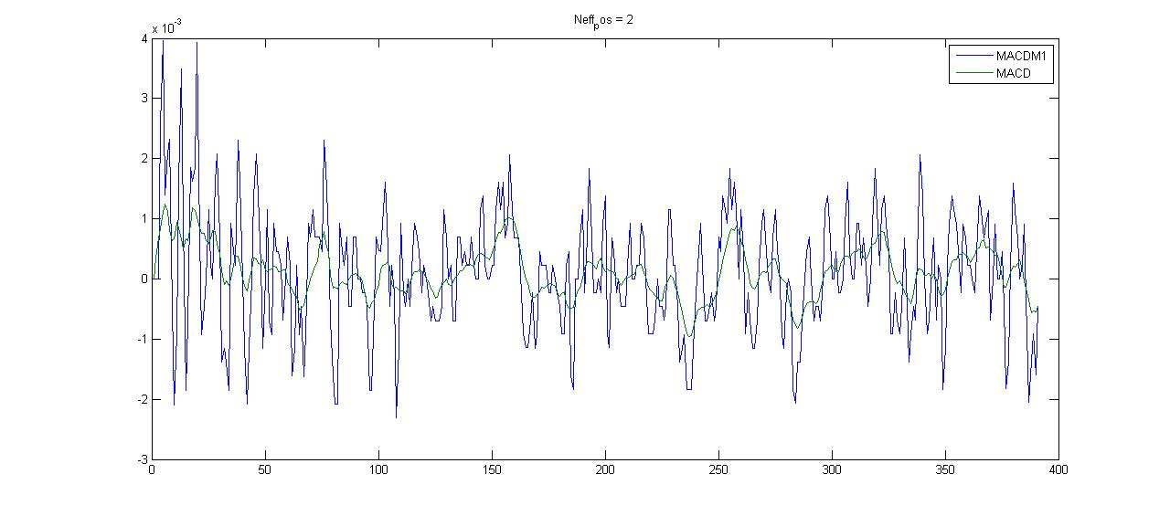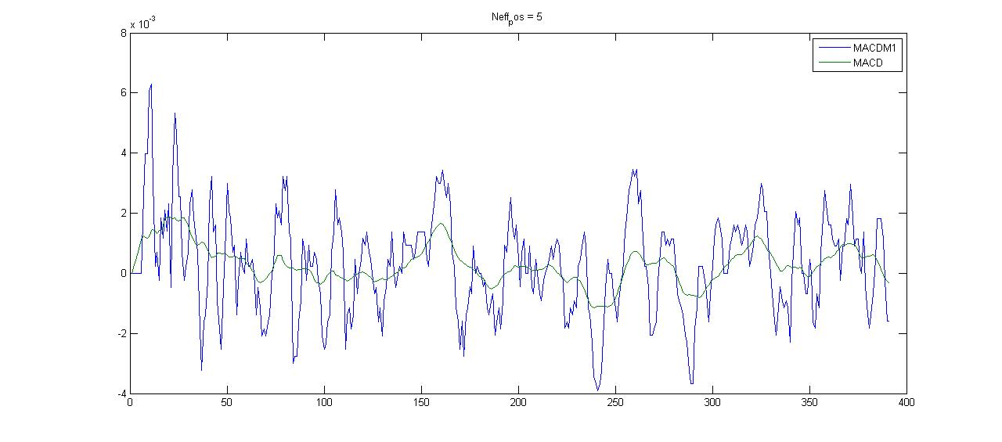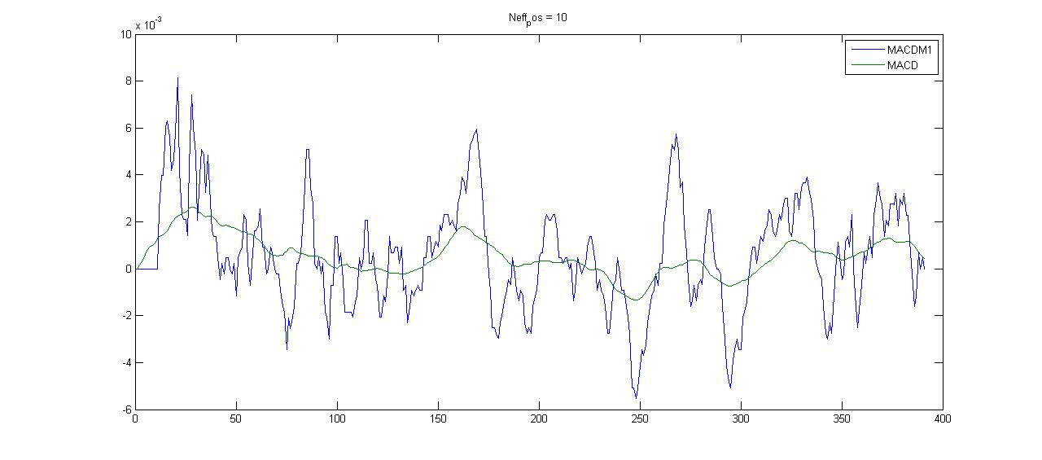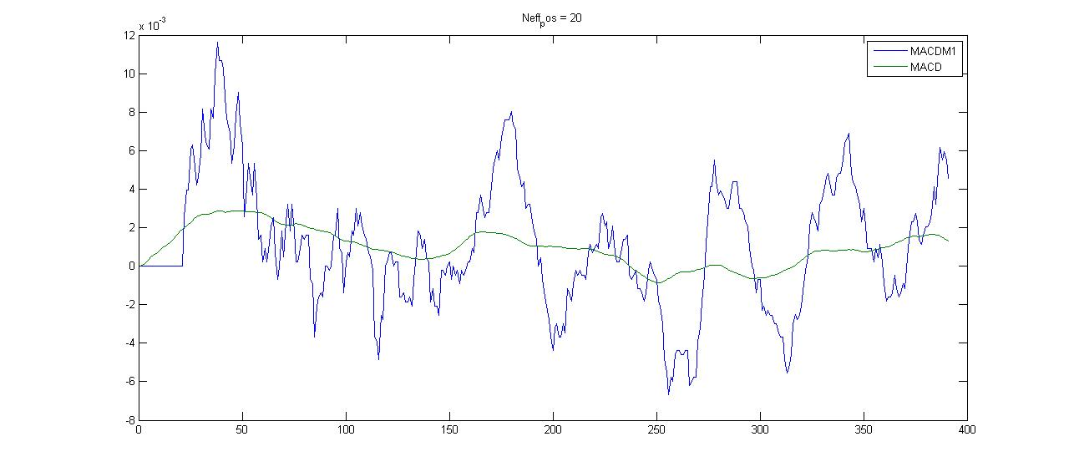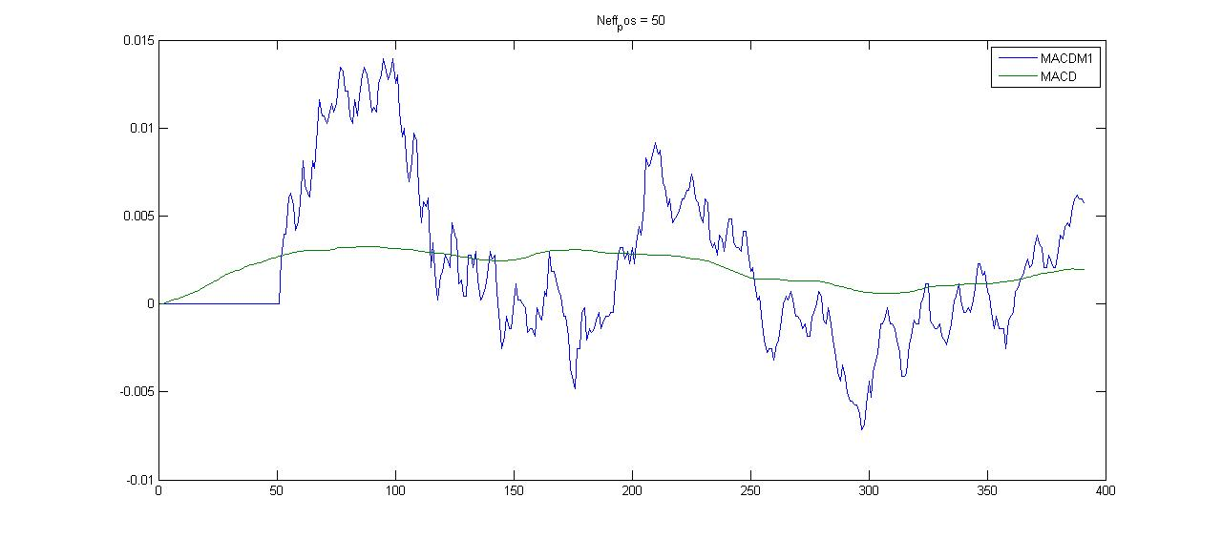

Macd-M1 is the subtraction of two delta function. So it computes the return, which is more rough. MACD is the subtraction of two EMA series, and it is smoother since it is a weighted average. And the larger Neff, the smoother MACD is, and it seems that macdM1 is also less rough, which might be a result of longer return and less noise.

10. Smoothing a Trade-Bin Series

## (a) EMA

## (b) Compound Smoothing: explain clearly the gain of each impulse response, and why offsets that I added back after each convolution are correct.

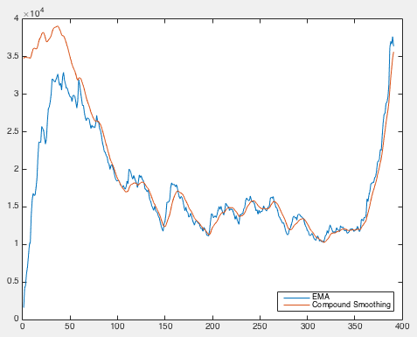

According to the graph, EMA and Unit Step attach to each other when it goes further. EMA series start from 0 since it ignored previous volumes. The gain of the EMA Impulse function is 1 while the gain of the Unit Step function is the length of the window, so in order to make them as same scale, we multiply tr[0] by the length.

MACD gain equals to the difference between two unit step function. Since we dividedit by N makeing the gain as of -1, we add tr[0] back.

## (c) Compound Smoothing Impulse Response: compare this result to the one above. Explain why ∆N needs to be considered.

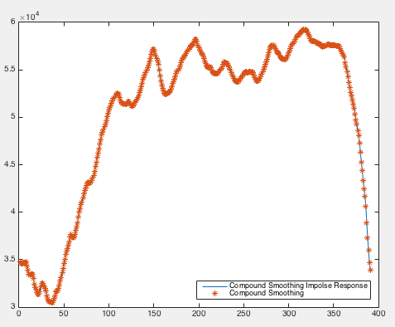

They are exactly matching. They reason why delta-N need to be considered is the same as above.

11. Circular Convolution

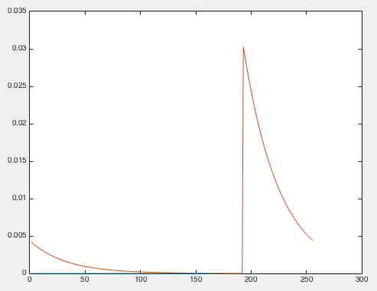

Circular Convolution of the two functions occurs when one of the mis convolved in the normal way with a periodic summation of the other function. According to the graph, the circular convolution starts with a position number rather than 0, as of non-casualility region. The origin of this artifact comes from no impulse at this moment. Circular convolution is looking into future at non-casuality region.

If the impulse were a significant market event and we use circular convolution, but the assumption of circular convolution is circular while this impulse is of course rare and impossibly circular. The assumption of this model is incorrect, it’s a model error and you would have incorrect prediction of similar impulse as of the significant shock.